**Day4**

C++ Class & Object

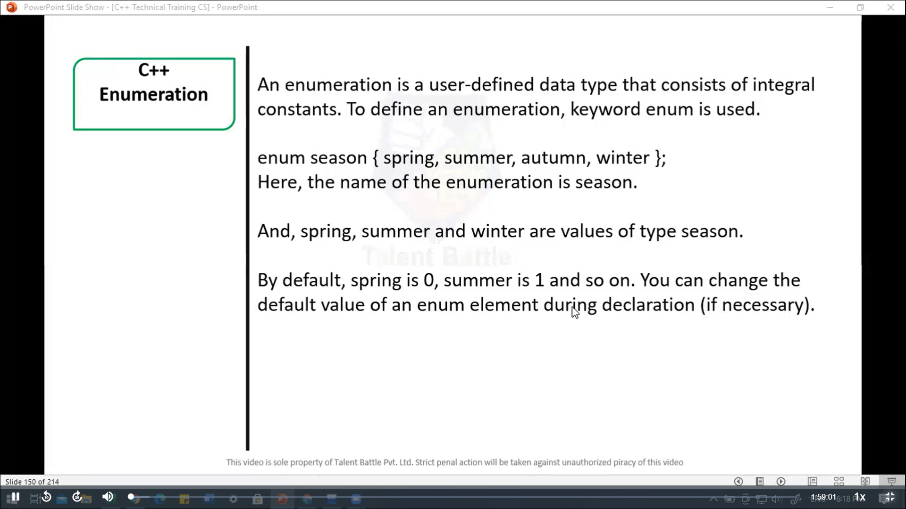

// Enumeration

#include <iostream>

using namespace ***std***;

enum week { Sunday***,*** Monday***,*** Tuesday***,*** Wednesday***,*** Thrsday***,*** Friday***,*** saturday

};

int *main*(){

  week today;

  today = Wednesday;

  cout ***<<*** "Day" ***<<*** today + 1;

  return 0;

}

/*

Day4

--------------------------------

Process exited after 0.1415 seconds with return value 0

*/

//=========================================================

// Enumeration ex: 2

#include <iostream>

using namespace ***std***;

enum seasons{

  spring = 34***,***

  summer = 4***,***

  automn = 9***,***

  winter = 32

};

int *main*(){

  seasons s;

  s = summer;

  cout *<<* "Summer = " *<<* s *<<* *endl*;

  return 0;

}

/*

Summer = 4

--------------------------------

Process exited after 0.01113 seconds with return value 0

*/

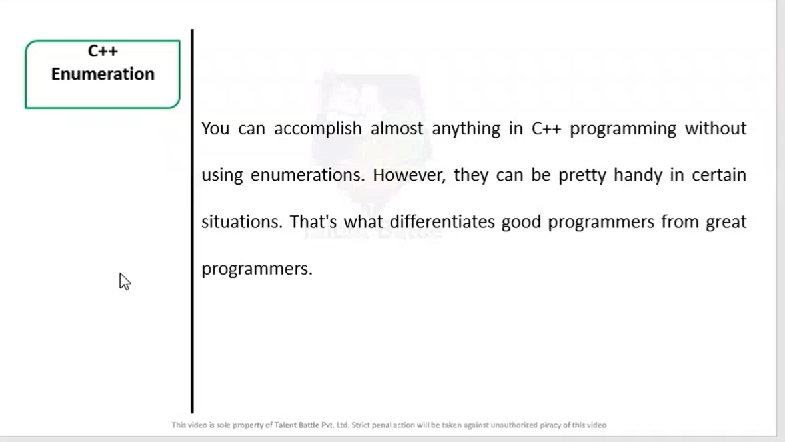

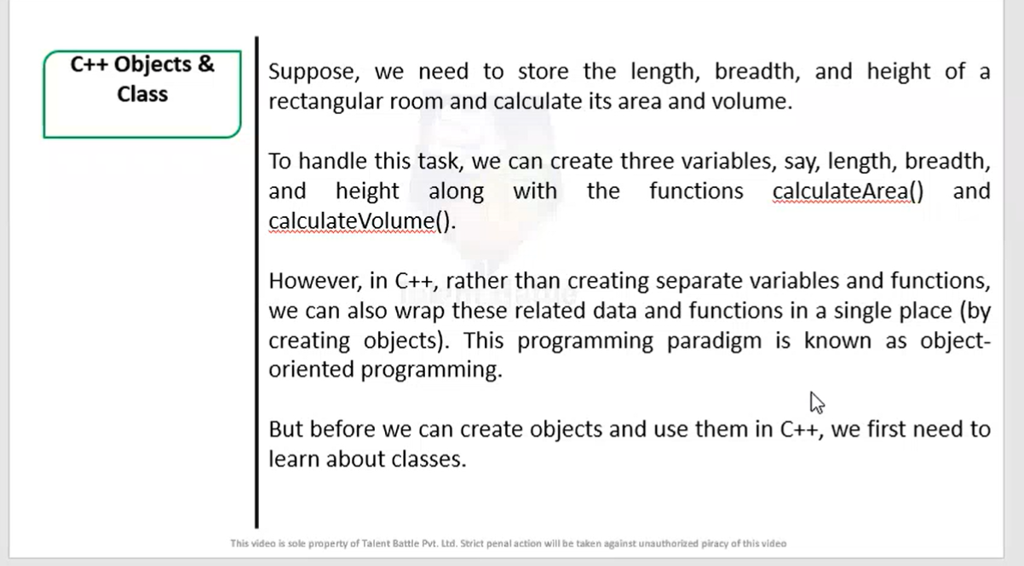

object

**This is Object oriented programming**

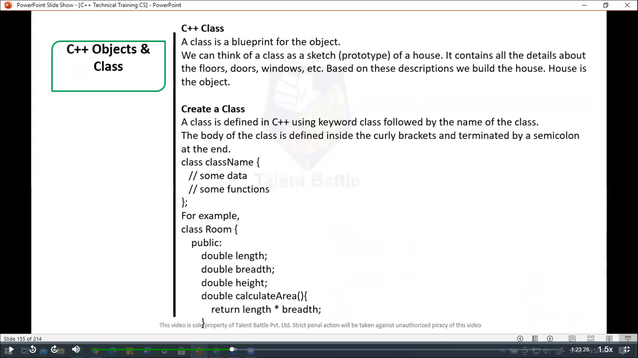 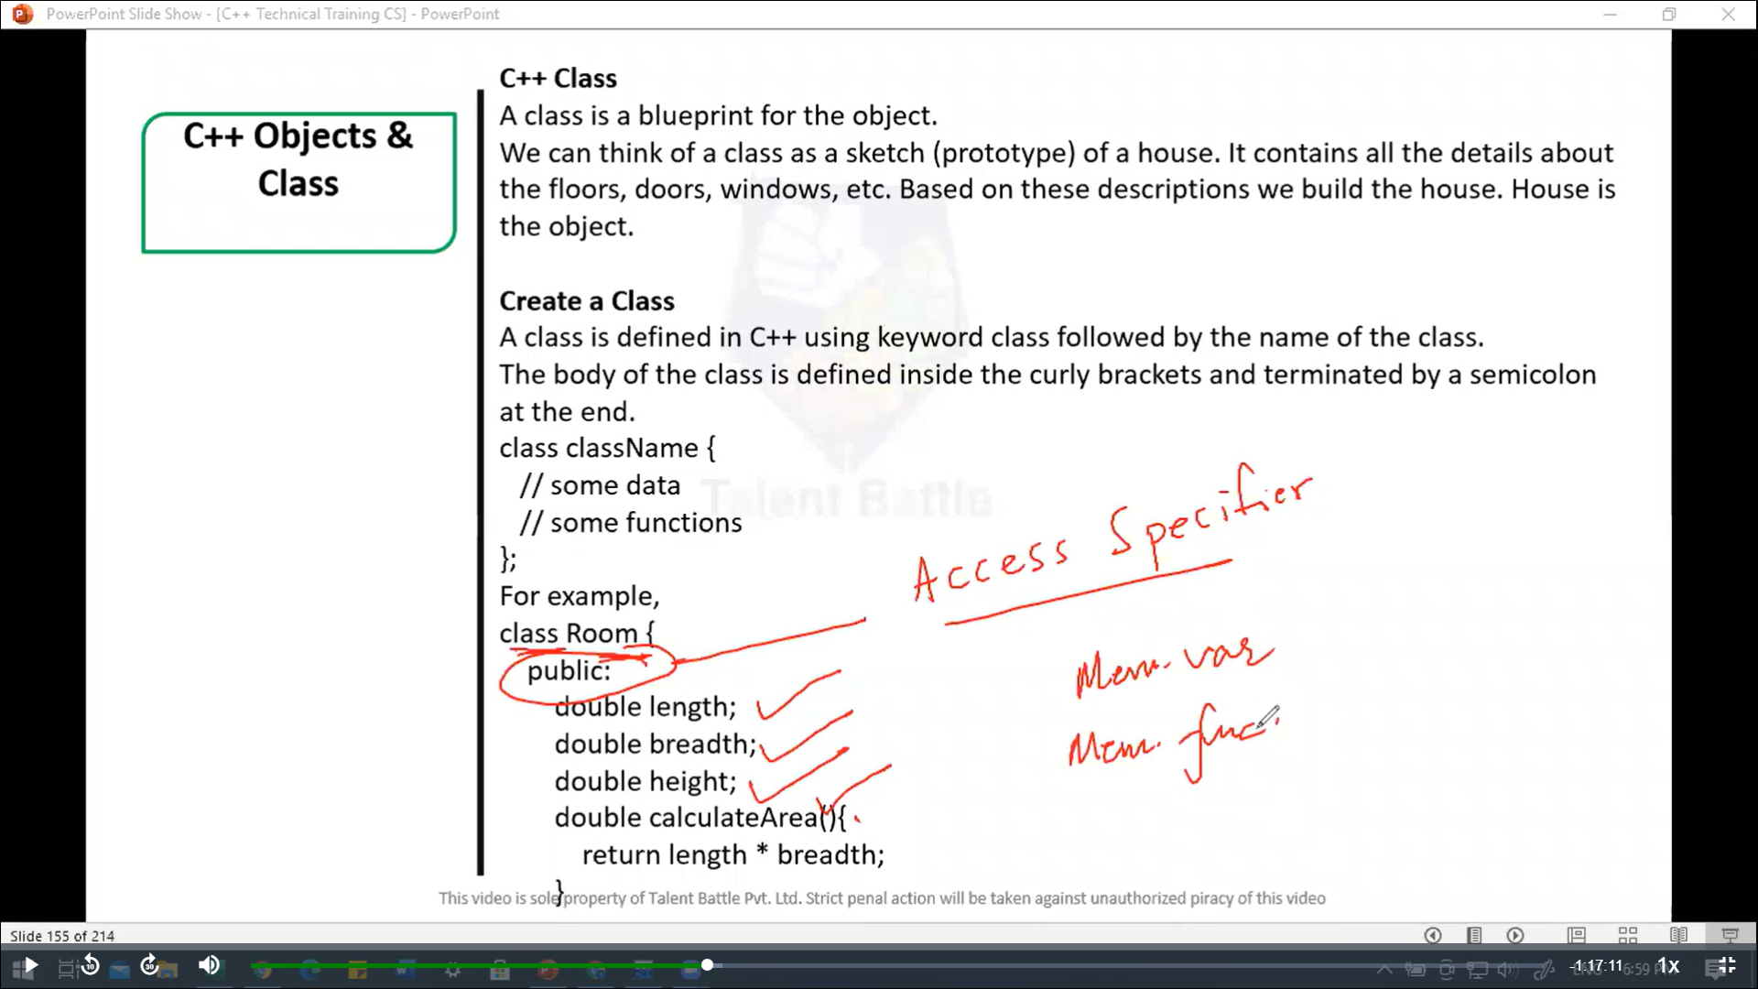 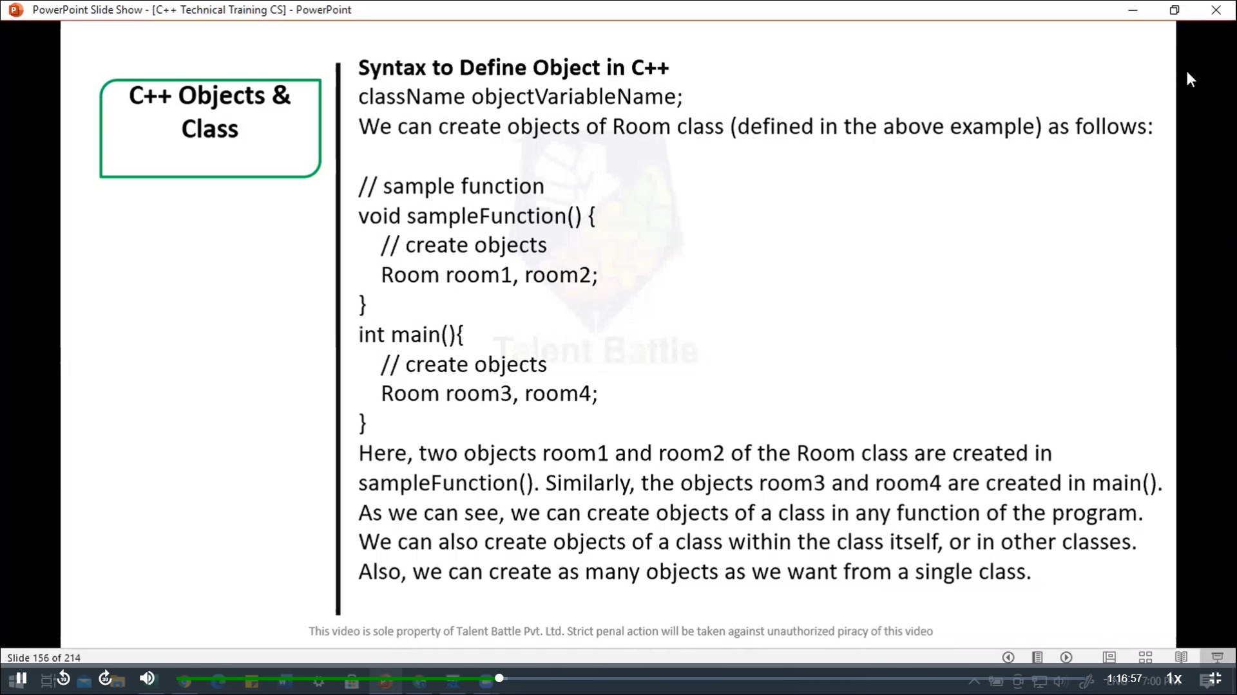 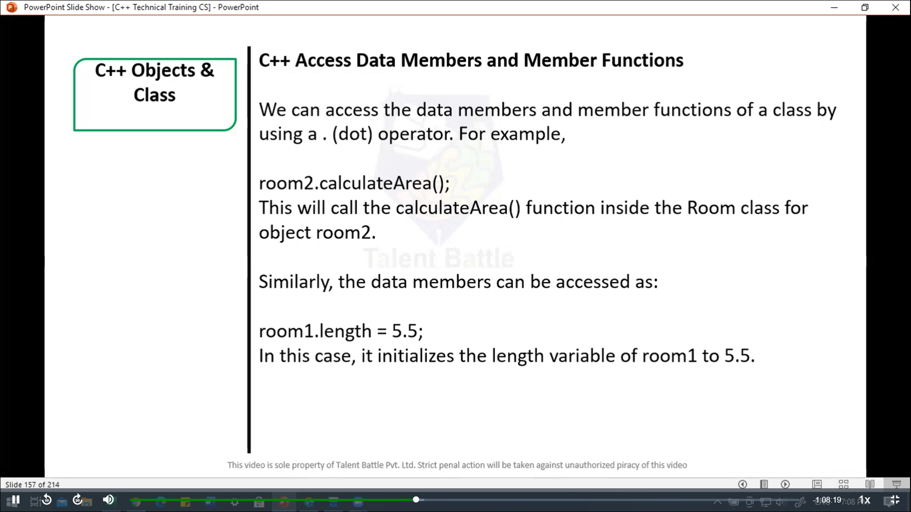

//=========================================================

// C++ Objects & Class

// program to illustrate the working of objects and

// class in c++ programming

#include <iostream>

using namespace ***std***;

// create a class

*class* Room {

  public***:***

    double length;

    double breadth;

    double height;

    double *calculateArea*(){

      return length * breadth;

    }

    double *calculateVolume*(){

      return length * breadth * height;

    }

};

int *main*(){

  // create object of Room  class

  Room room1;

  // assign values to data members

  room1***.***length = 42.5;

  room1***.***breadth = 30.8;

  room1***.***height = 19.2;

  // calculate and display the area and volume of the room

  cout *<<* "Area of Room = " *<<* room1***.****calculateArea*() *<<* *endl*;

  cout *<<* "Volume of Room = " *<<* room1***.****calculateVolume*() *<<* *endl*;

  return 0;

}

/*

Area of Room = 1309

Volume of Room = 25132.8

--------------------------------

Process exited after 0.1369 seconds with return value 0

Press any key to continue . . .

*/

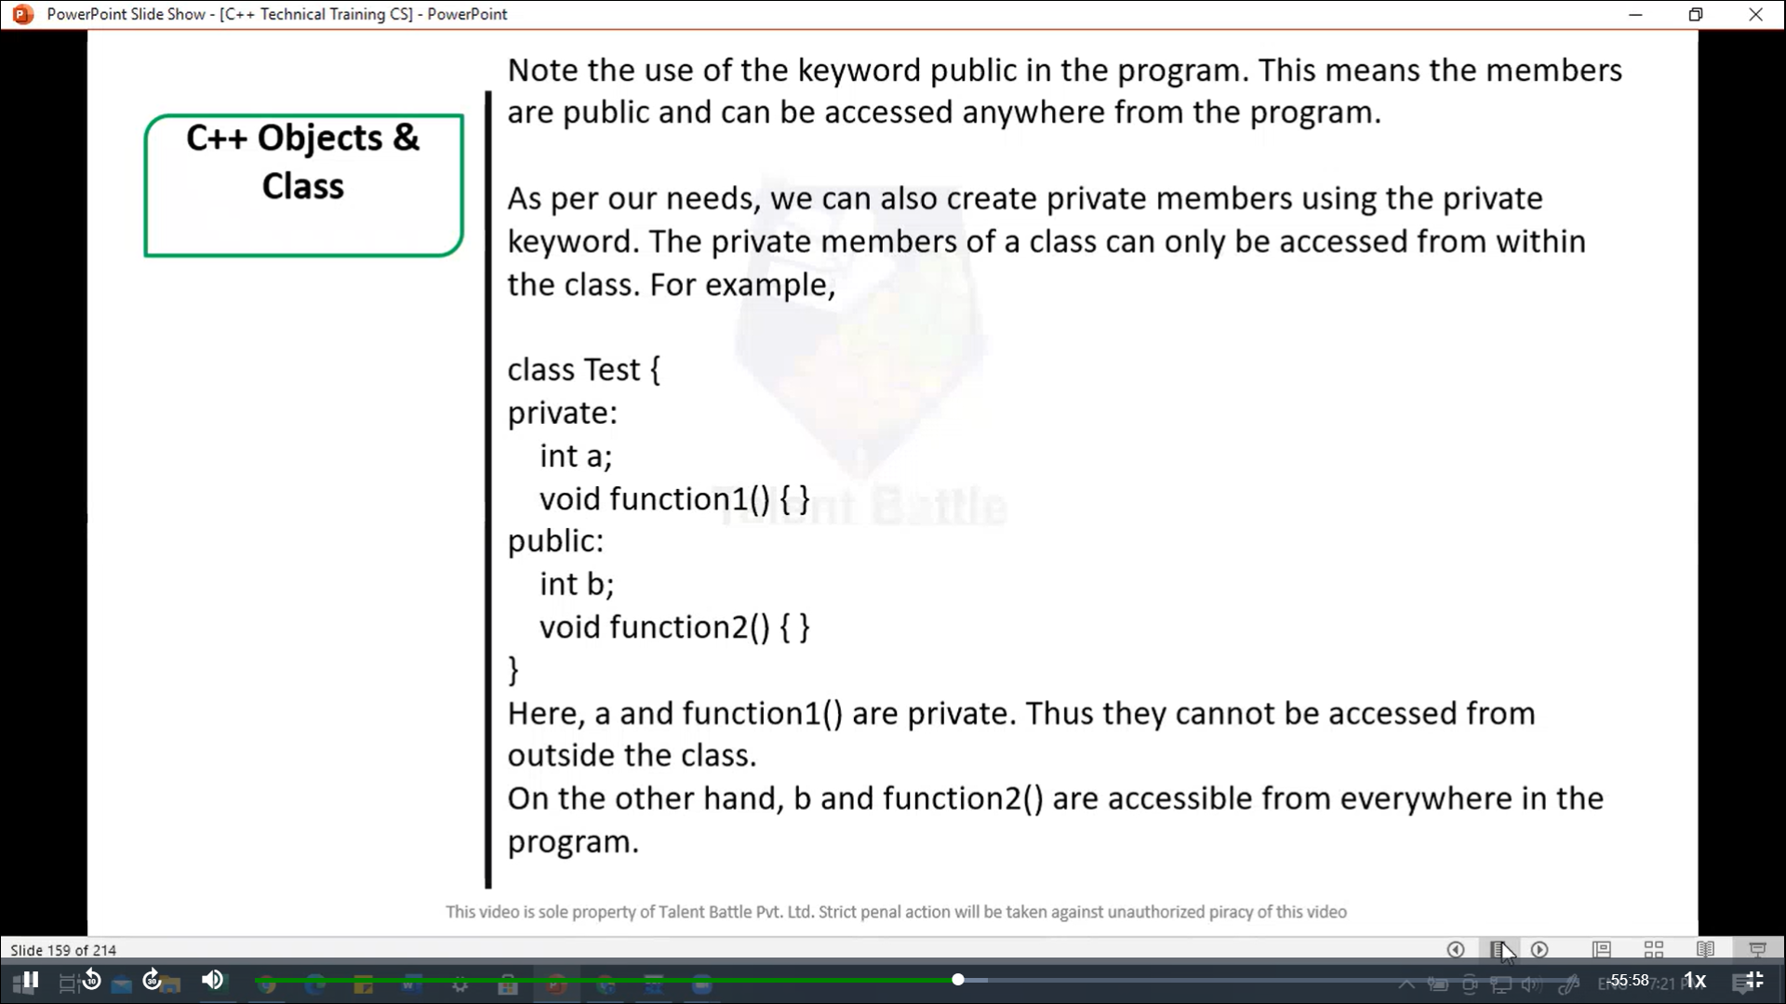

//===============================================

// Program to illustrate the working of Public and private in C++ class

#include <iostream>

using namespace ***std***;

*class* Room{

  private***:***

    double length;

    double breadth;

    double height;

  public***:***

    // function to initialize private variables

    void *getData*(double ***len,*** double ***brth,*** double ***hgt***){

      length = ***len***;

      breadth = ***brth***;

      height = ***hgt***;

    }

    double *calculateArea*(){

      return length * breadth;

    }

    double *calculateVolume*(){

      return length * breadth * height;

    }

};

int *main*(){

  // create object of Room class

  Room room1;

  // pass the values of private variables as arguments

  room1***.****getData*(42.5***,*** 30.8***,*** 19.2);

  cout *<<* "Area of Room = " *<<* room1***.****calculateArea*() *<<* *endl*;

  cout *<<* "Volume of Room = " *<<* room1***.****calculateVolume*() *<<* *endl*;

  return 0;

}

/*

Area of Room = 1309

Volume of Room = 25132.8

--------------------------------

Process exited after 0.06076 seconds with return value 0

*/

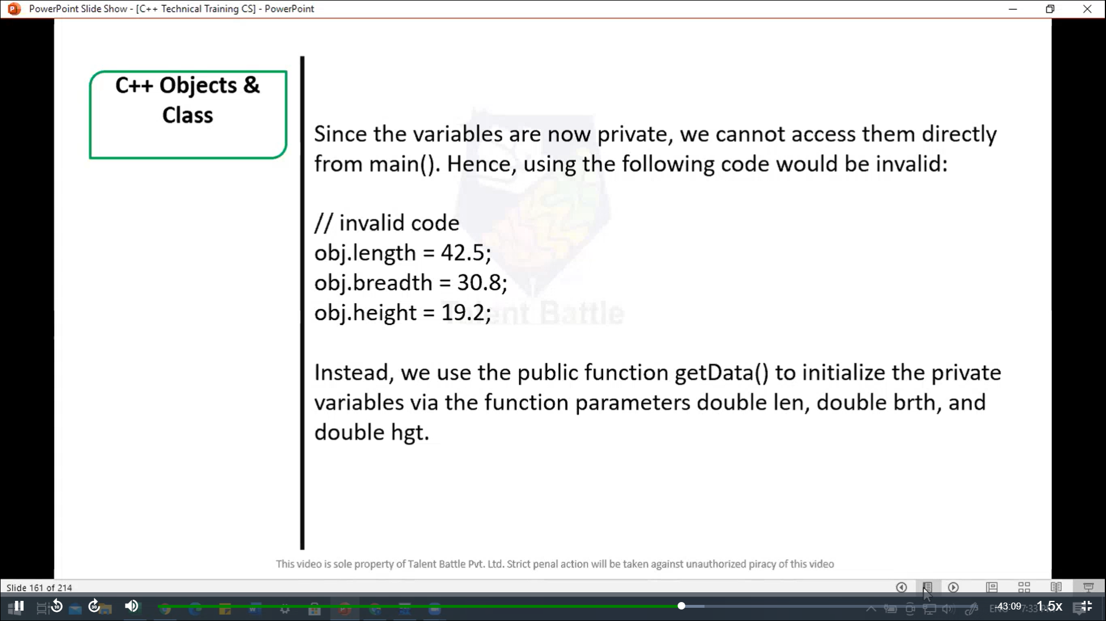 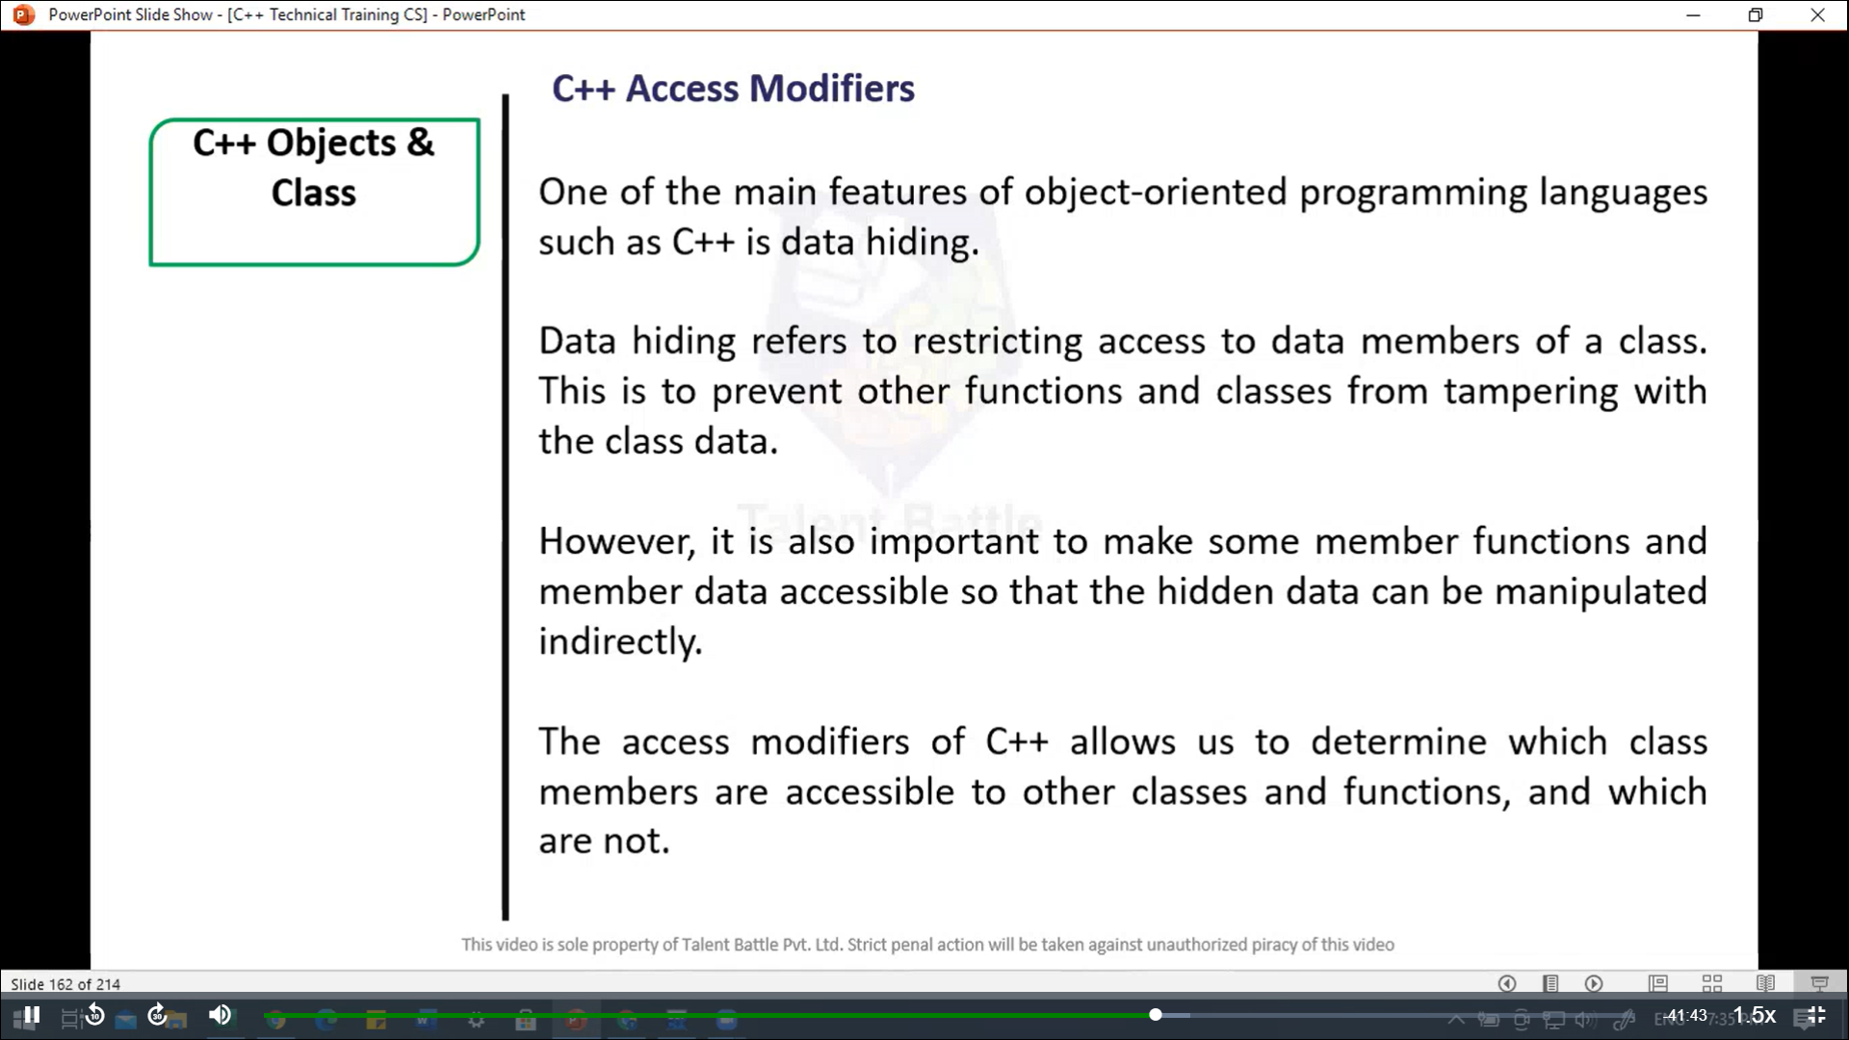 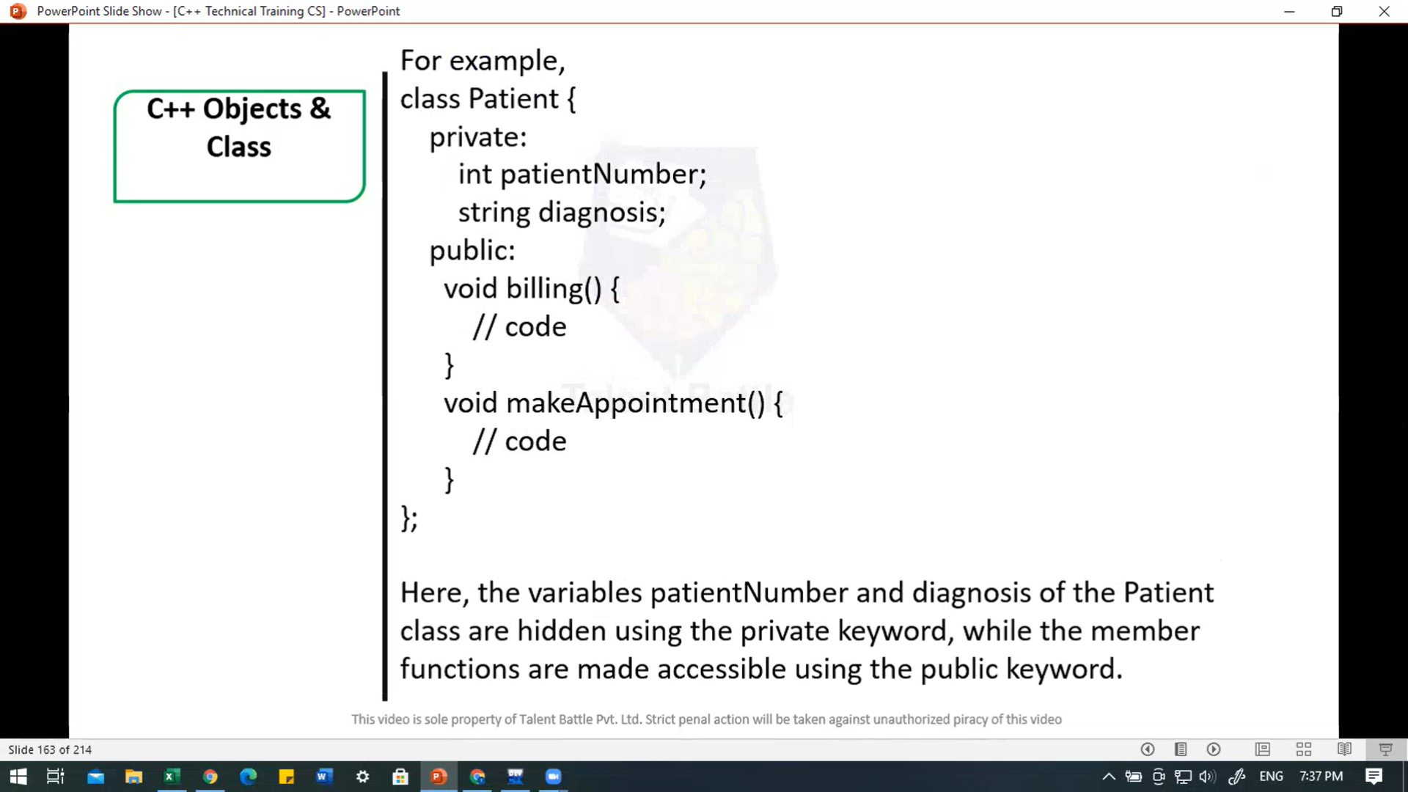 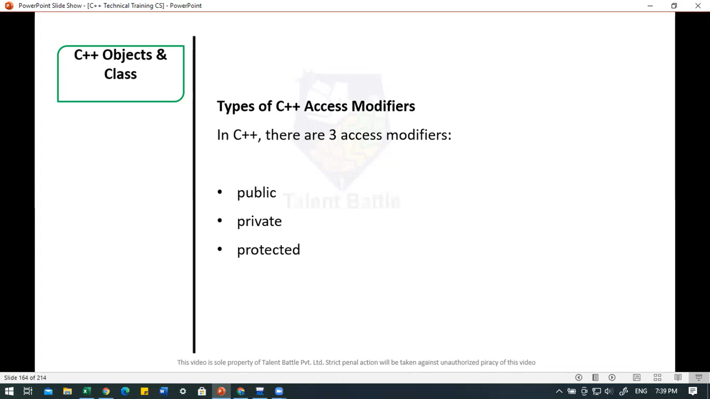 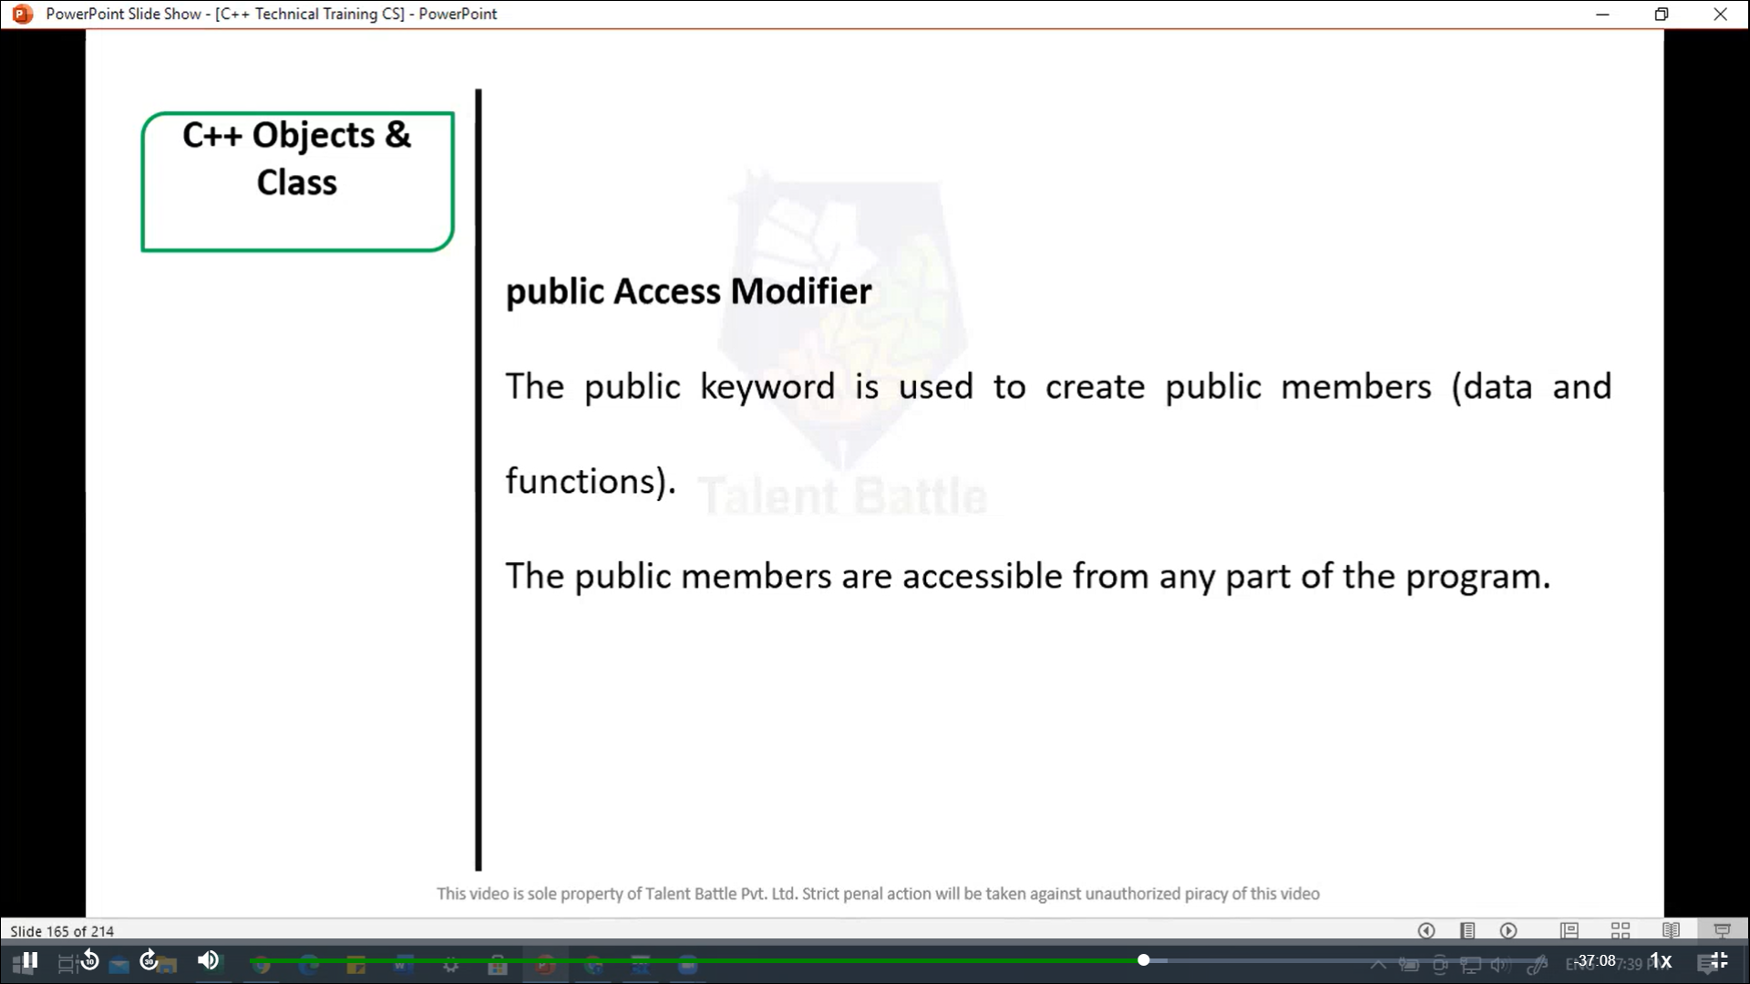 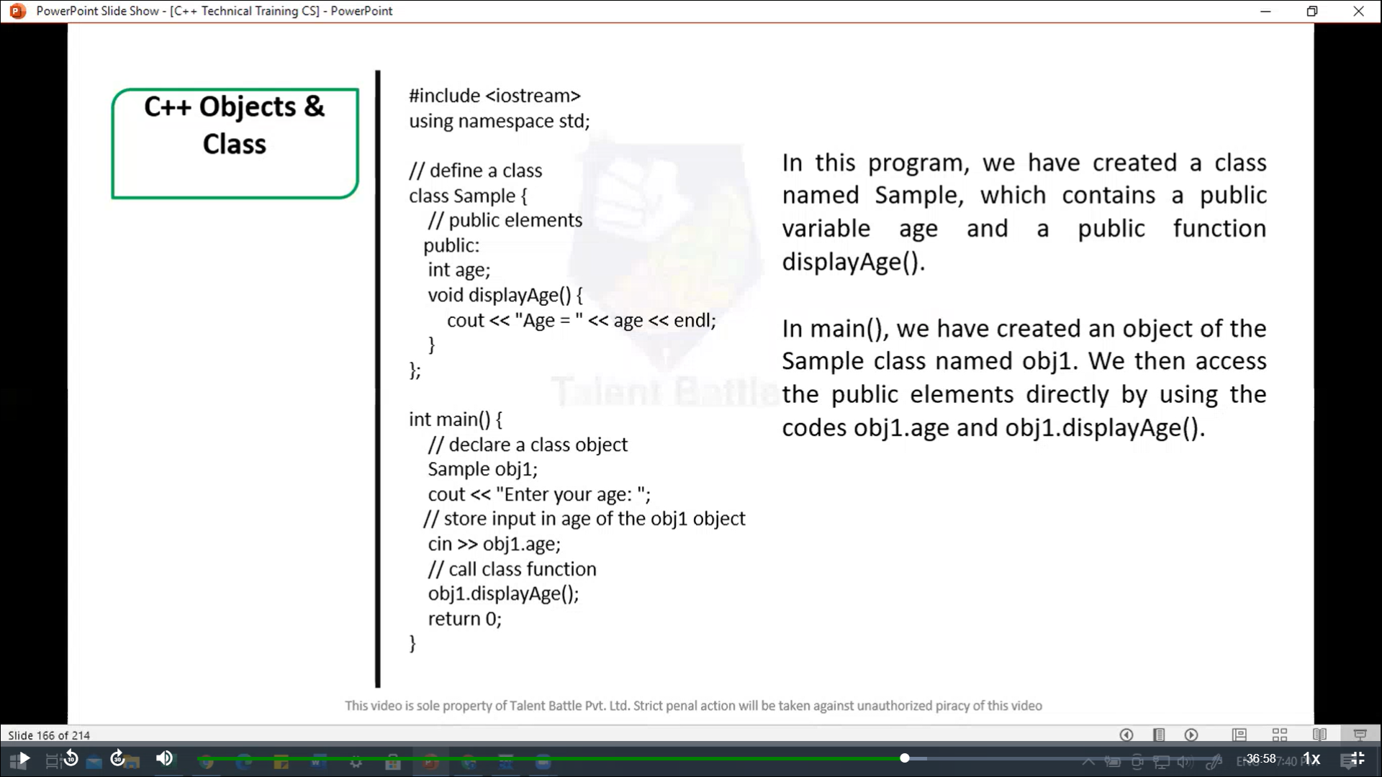

//==========================================================

/*

In this program, we have created a class named Sample, which

contains a public variable age and a public function displayAge().

In main(), we have created an object of the Sample class named

obj1. We then access the public elements directly by using the

codes obj1.age and obj1.displayAge().

*/

#include <iostream>

using namespace ***std***;

// define a class

*class* Sample {

  // public elements

  public***:***

    int age;

    void *displayAge*(){

      cout *<<* "Age = " *<<* age *<<* *endl*;

    }

};

int *main*(){

  // declare a class object

  Sample obj1;

  cout *<<* "Enter your age: ";

  // store input in age of the obj1 object

  cin *>>* obj1***.***age;

  // call class function

  obj1***.****displayAge*();

  return 0;

}

/*

Enter your age: 22

Age = 22

--------------------------------

Process exited after 2.809 seconds with return value 0

*/

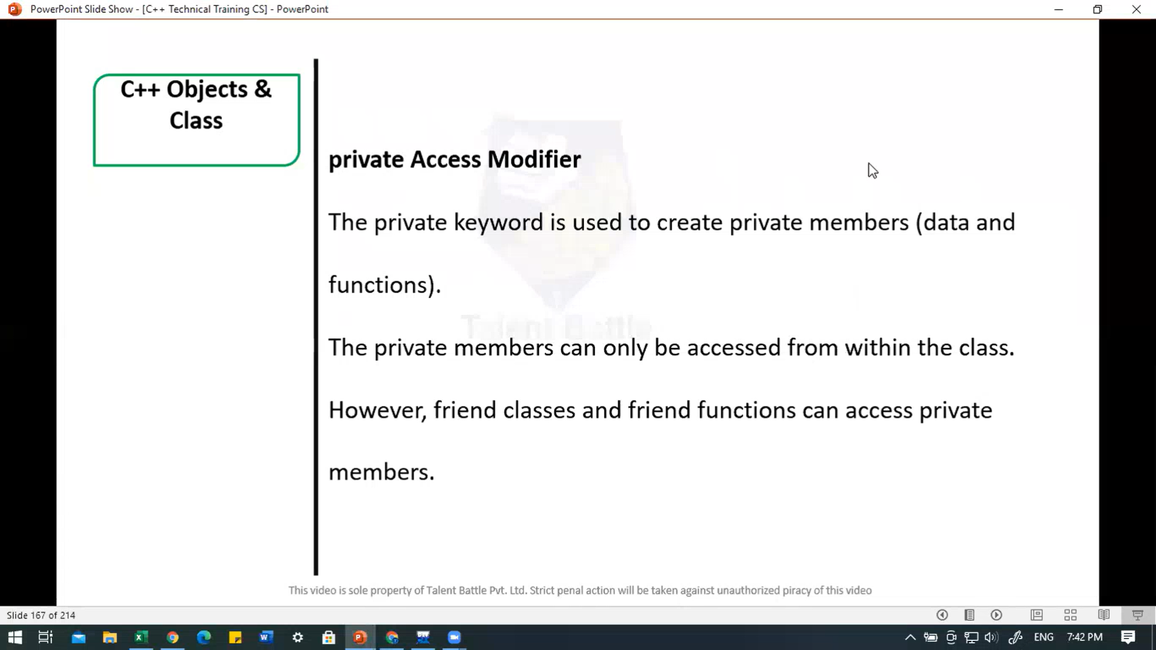 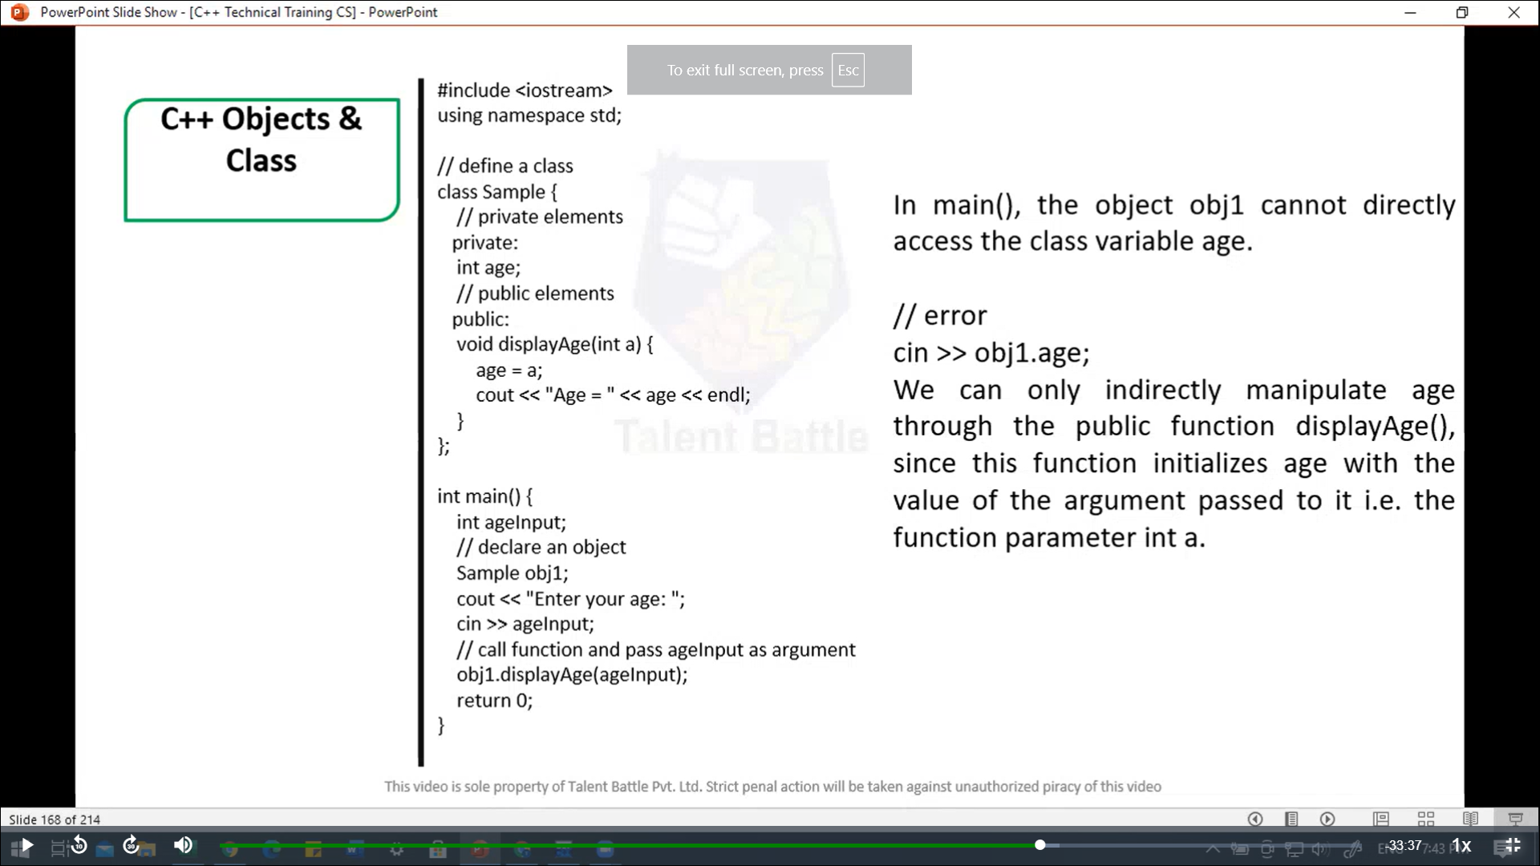

//===================================================

/*

In main(), the object obj1 cannot directly acces the class

variable age.

// error

cin >> obj1.age;

We can only indirectly manipulate age through the public

funciton displayAge(), since this function initializes age

with the value of the argument passed to it i.e the funciton

parameer int a.

*/

#include <iostream>

using namespace ***std***;

// define a class

*class* Sample {

  // private elements

  private***:***

    int age;

  // public elements

  public***:***

    void *displayAge*(int ***a***){

      age = ***a***;

      cout *<<* "Age = " *<<* age *<<* *endl*;

    }

};

int *main*(){

  int ageInput;

  // declare an object

  Sample obj1;

  cout *<<* "Enter you age: ";

  cin *>>* ageInput;

  // call function and pass ageInput as argument

  obj1***.****displayAge*(ageInput);

  return 0;

}

/*

Enter you age: 22

Age = 22

--------------------------------

Process exited after 1.974 seconds with return value 0

*/

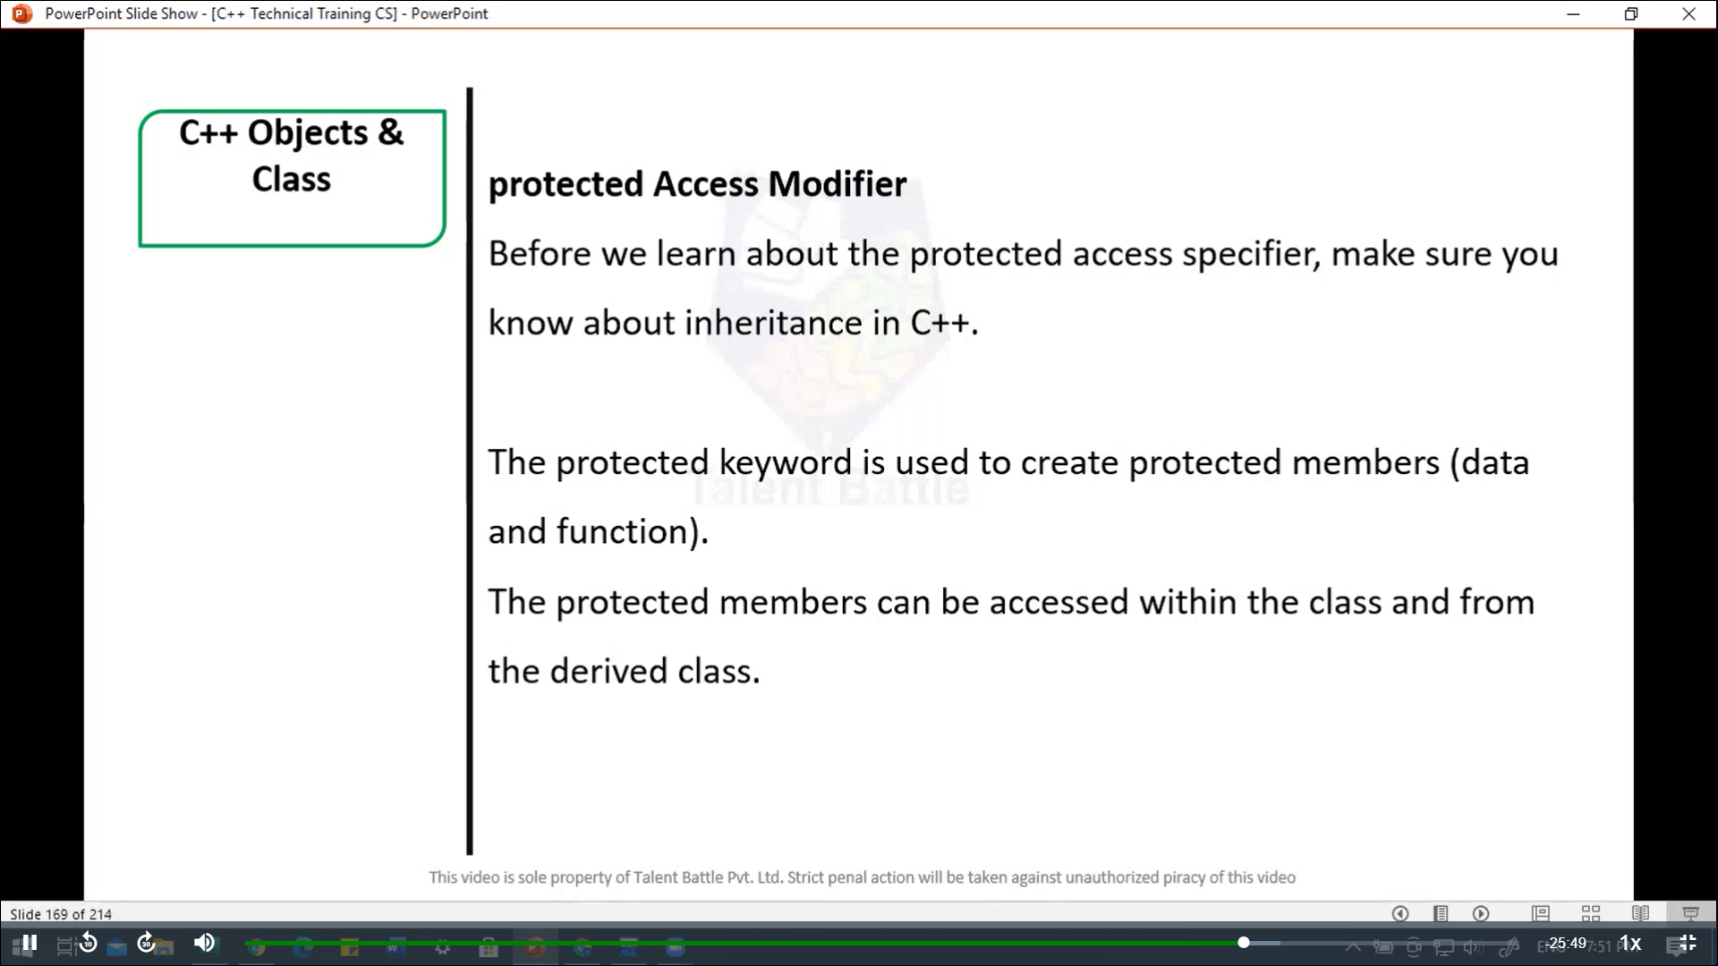

//============================================

// Protected access modifier

#include <iostream>

using namespace ***std***;

// declare parent class

*class* Sample {

  // protected elements

  protected***:***

    int age;

};

// declare child class

*class* SampleChild ***:*** public Sample {

  public***:***

    void *displayAge*(int ***a***){

      age = ***a***;

      cout *<<* "Age = " *<<* age *<<* *endl*;

    }

};

int *main*(){

  int ageInput;

  // declare object of child class

  SampleChild child;

  cout *<<* "Enter you age:  ";

  cin *>>* ageInput;

  // call child class function

  // pass ageInput as argument

  child***.****displayAge*(ageInput);

  return 0;

}

/*

Enter you age:  22

Age = 22

--------------------------------

Process exited after 2.936 seconds with return value 0

*/

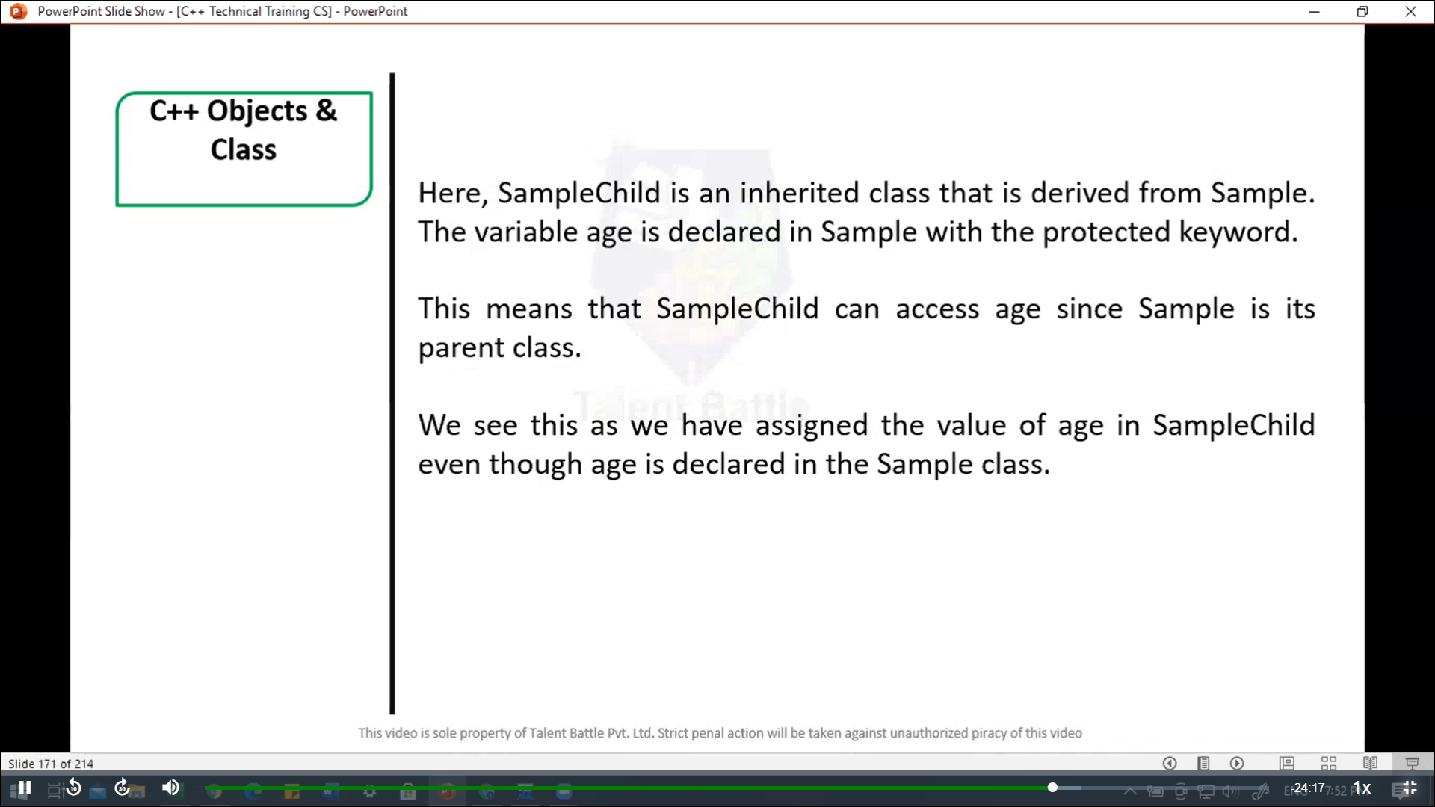 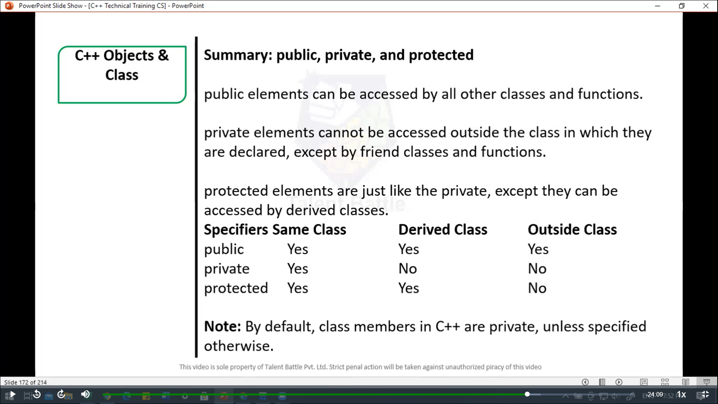 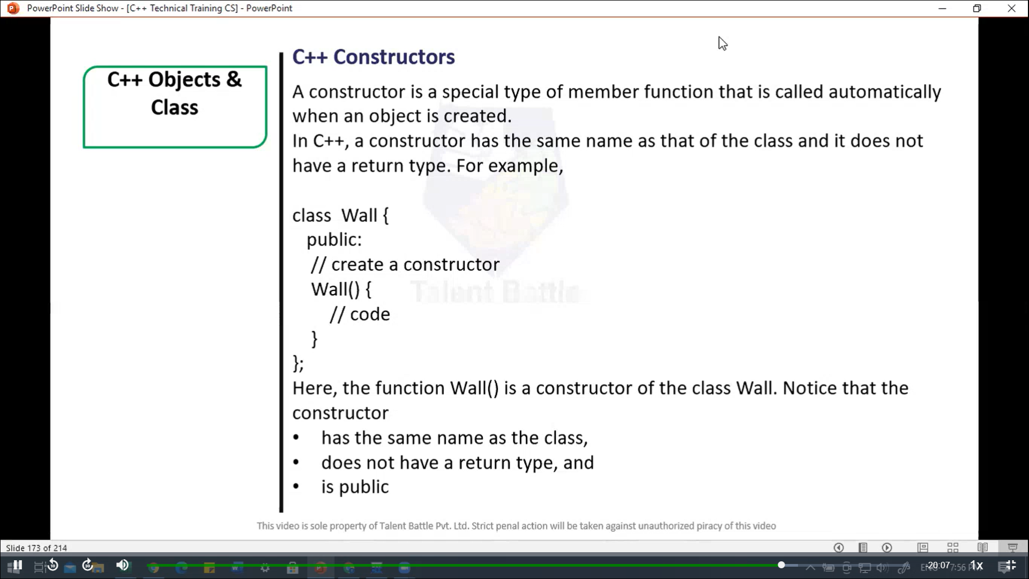 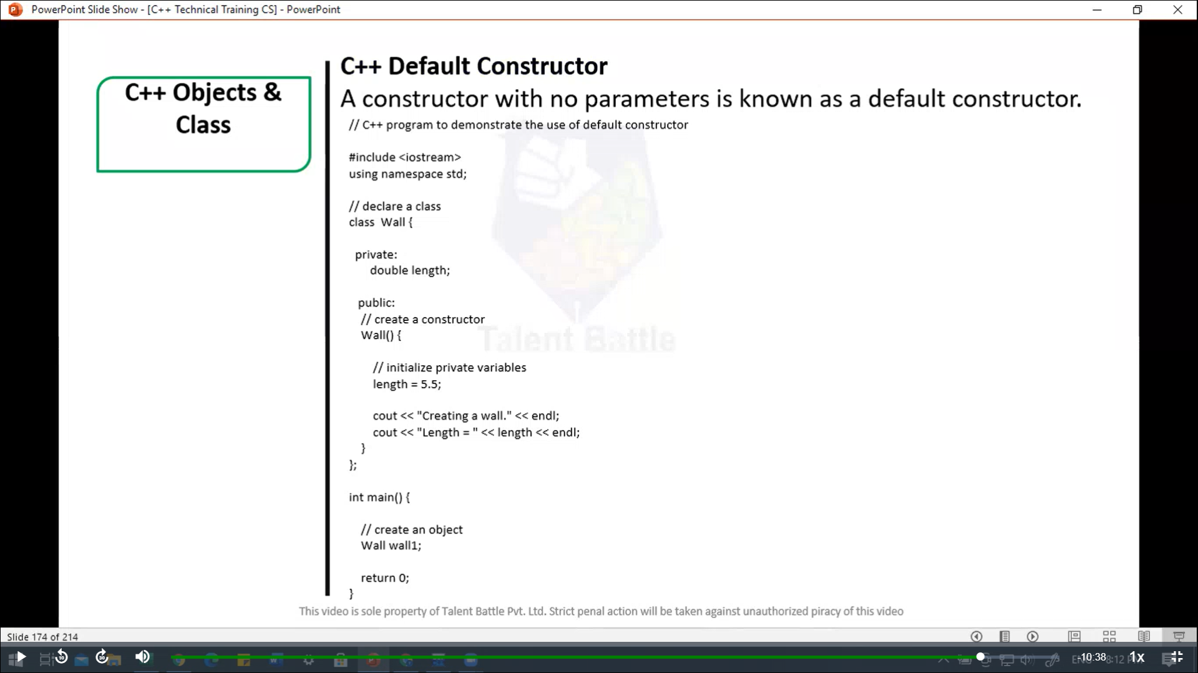 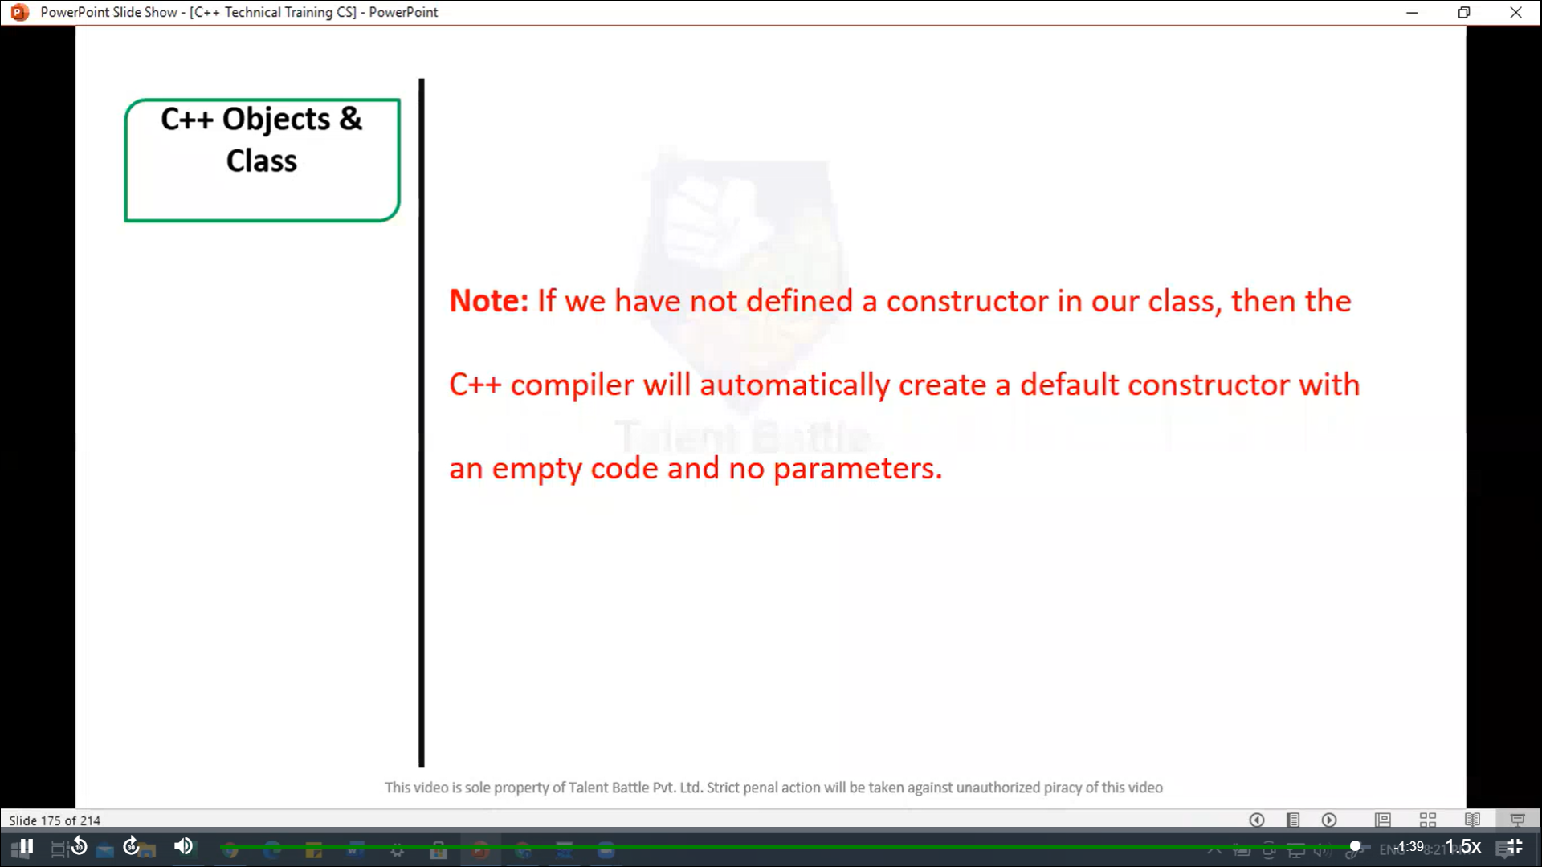

// C++ Default Constructor

/*

A constructor with no parameters is known as a default constructor.

C++ program to demonstrate the use of default constructor

*/

#include <iostream>

using namespace ***std***;

// declare a class

*class* Wall{

  private***:***

    double length;

  public***:***

    // create a constructor

*Wall*(){

      // initialize private variables

      length = 5.5;

      cout ***<<*** "Create a wall." ***<<*** endl;

      cout ***<<*** "Length = " ***<<*** length ***<<*** endl;

    }

};

int *main*(){

  // create an object

  Wall wall1;

  return 0;

}

/*

Create a wall.

Length = 5.5

--------------------------------

Process exited after 0.1771 seconds with return value 0

*/